**ENGN2020 – HOMEWORK3**

**Ming Xu**

### Problem 2(K8-4-5)

Matrix A = $\left[\begin{matrix}-5 & 0 & 15 \\ 3 & 4 & -9 \\ -5 & 0 & 15\end{matrix}\right]$, Matrix P =

Then, P-1 = , therefore $\hat{A}=P^{-1}AP=\left[\begin{matrix}4 & 3 & -9 \\ 0 & -5 & 15 \\ 0 & -5 & 15\end{matrix}\right]$

For matrix A, the characteristic determinant gives the characteristic equation:

$$\left(4-λ\right)\left(-5-λ\right)\left(15-λ\right)+300=0$$

Then we get: $λ^{3}-14λ^{2}+40λ=0$

The roots, which are also eigenvalues of A, are $λ_{1}=0$, $λ_{2}=10$, $λ_{3}=4$

For $λ=0:$

$A-λI=A=\left[\begin{matrix}-5 & 0 & 15 \\ 3 & 4 & -9 \\ -5 & 0 & 15\end{matrix}\right]$ = $\left[\begin{matrix}-5 & 0 & 15 \\ 3 & 4 & -9 \\ 0 & 0 & 0\end{matrix}\right]$ = $\left[\begin{matrix}-5 & 0 & 15 \\ 3 & 4 & -9 \\ 0 & 0 & 0\end{matrix}\right]=\left[\begin{matrix}-5 & 0 & 15 \\ 0 & 4 & 0 \\ 0 & 0 & 0\end{matrix}\right]$

Let $x_{1}=3$, then $x_{2}=0$, $x_{3}=1$

So, an eigenvector of A corresponding to $λ=0$ is ${\left[\begin{matrix}3 & 0 & -1\end{matrix}\right]}^{T}$

For $λ=10:$

$A-λI=\left[\begin{matrix}-15 & 0 & 15 \\ 3 & -6 & -9 \\ -5 & 0 & 5\end{matrix}\right]$ = $\left[\begin{matrix}-5 & 0 & 5 \\ 1 & -2 & -3 \\ 0 & 0 & 0\end{matrix}\right]$ = $\left[\begin{matrix}1 & -2 & -3 \\ -5 & 0 & 5 \\ 0 & 0 & 0\end{matrix}\right]=\left[\begin{matrix}1 & -2 & -3 \\ 0 & -10 & -10 \\ 0 & 0 & 0\end{matrix}\right]$

Let $x_{3}=1$, then $x_{1}=1$, $x_{2}=-1$

So, an eigenvector of A corresponding to $λ=10$ is ${\left[\begin{matrix}1 & -1 & 1\end{matrix}\right]}^{T}$

For $λ=4:$

$A-λI=\left[\begin{matrix}-9 & 0 & 15 \\ 3 & 0 & -9 \\ -5 & 0 & 11\end{matrix}\right]$ = $\left[\begin{matrix}-5 & 0 & 11 \\ 3 & 0 & -9 \\ 0 & 0 & -12\end{matrix}\right]$

$x_{3}=0$, and $x_{1}=0$, $x_{2}$ can be anything, let $x_{2}=1$

So, an eigenvector of A corresponding to $λ=4$ is ${\left[\begin{matrix}0 & 1 & 0\end{matrix}\right]}^{T}$

For matrix $\hat{A}$, the characteristic determinant gives the characteristic equation: $λ^{3}-14λ^{2}+40λ=0$

The roots, which are the same eigenvalues of A, are $λ_{1}=0$, $λ_{2}=10$, $λ_{3}=4$

For $λ=0:$

$$\hat{A}-λI=A=\left[\begin{matrix}4 & 3 & -9 \\ 0 & -5 & 15 \\ 0 & -5 & 15\end{matrix}\right]=\left[\begin{matrix}4 & 3 & -9 \\ 0 & -5 & 15 \\ 0 & 0 & 0\end{matrix}\right]$$

Let $x_{2}=3$, then $x_{3}=1$, $x_{1}=0$

So, an eigenvector of $\hat{A}$ corresponding to $λ=0$ is ${\left[\begin{matrix}0 & 3 & 1\end{matrix}\right]}^{T}$

For $λ=10:$

$$\hat{A}-λI=\left[\begin{matrix}-6 & 3 & -9 \\ 0 & -15 & 15 \\ 0 & -5 & 5\end{matrix}\right]=\left[\begin{matrix}-2 & 1 & -3 \\ 0 & -5 & 5 \\ 0 & 0 & 0\end{matrix}\right]$$

Let $x_{2}=1$, then $x_{3}=1$, $x_{1}=-1$

So, an eigenvector of $\hat{A}$ corresponding to $λ=10$ is ${\left[\begin{matrix}-1 & 1 & 1\end{matrix}\right]}^{T}$

For $λ=4:$

$$\hat{A}-λI=\left[\begin{matrix}4 & 3 & -9 \\ 0 & -5 & 15 \\ 0 & -5 & 15\end{matrix}\right]=\left[\begin{matrix}0 & 3 & 9 \\ 0 & -9 & 15 \\ 0 & -5 & 11\end{matrix}\right]$$

$x_{2}=0$, and $x_{3}=0$, $x_{2}$ can be anything, let $x_{1}=1$

So, an eigenvector of $\hat{A}$ corresponding to $λ=4$ is ${\left[\begin{matrix}1 & 0 & 0\end{matrix}\right]}^{T}$

It can be calculated that ${\left[\begin{matrix}0 & 3 & 1\end{matrix}\right]}^{T}=P{\left[\begin{matrix}3 & 0 & -1\end{matrix}\right]}^{T}$

${\left[\begin{matrix}-1 & 1 & 1\end{matrix}\right]}^{T}=P{\left[\begin{matrix}1 & -1 & 1\end{matrix}\right]}^{T}$

${\left[\begin{matrix}1 & 0 & 0\end{matrix}\right]}^{T}=P{\left[\begin{matrix}0 & 1 & 0\end{matrix}\right]}^{T}$

### Problem 4(K20-7-1 to K20-7-6)

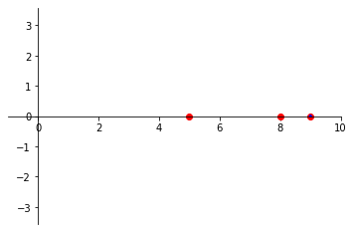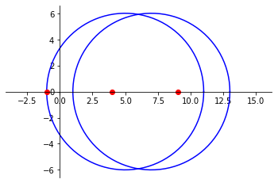**(a) K20-7-1:**  **(b) K20-7-2**

$A=\left[\begin{matrix}5 & 2 & 4 \\ -2 & 0 & 2 \\ 2 & 4 & 7\end{matrix}\right]$ $A=\left[\begin{matrix}5 & 0.01 & 0.01 \\ 0.01 & 8 & 0.01 \\ 0.01 & 0.01 & 9\end{matrix}\right]$

Figure 1: Gerschgorin disks of K20-7-1 Figure 1: Gerschgorin disks of K20-7-2

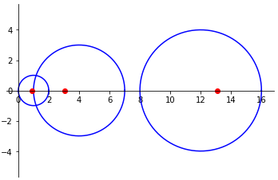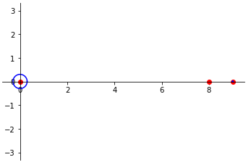**(c) K20-7-3:** **(d) K20-7-4:**

$A=\left[\begin{matrix}0 & 0.4 & -0.1 \\ -0.4 & 0 & 0.3 \\ 0.1 & -0.3 & 0\end{matrix}\right]$ $A=\left[\begin{matrix}1 & 0 & 1 \\ 0 & 4 & 3 \\ 1 & 3 & 12\end{matrix}\right]$

Figure 3: Gerschgorin disks of K20-7-3 Figure 4: Gerschgorin disks of K20-7-4

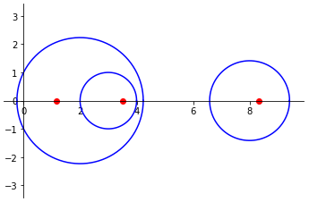**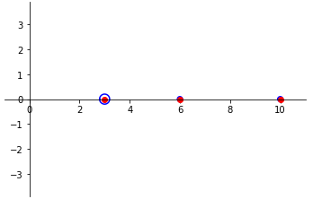(e) K20-7-5:**  **(f) K20-7-6:**

$A=\left[\begin{matrix}2 & i & 1+i \\ -i & 3 & 0 \\ 1-i & 0 & 8\end{matrix}\right]$ $A=\left[\begin{matrix}10 & 0.1 & -0.2 \\ 0.1 & 6 & 0 \\ -0.2 & 0 & 3\end{matrix}\right]$

Figure 5: Gerschgorin disks of K20-7-5 Figure 6: Gerschgorin disks of K20-7-6

### Problem 5(K8-4-6)

**(a)Trace:**

Let A be a $n×n$ matrix, $trace A=a_{11}+a_{22}+…+a_{nn}$.

For $A=\left[\begin{matrix}3 & 4 \\ 4 & -3\end{matrix}\right]$, trace A = 0, its eigen values are 5 and -5, the trace equals the sum of the eigenvalues.

For $A=\left[\begin{matrix}8 & -4 \\ 2 & 2\end{matrix}\right]$, trace A = 10, its eigen values are 6 and 4, the trace equals the sum of the eigenvalues.

For $A=\left[\begin{matrix}-5 & 0 & 15 \\ 3 & 4 & -9 \\ -5 & 0 & 15\end{matrix}\right]$, trace A = 14, its eigen values are 0, 4 and 10, the trace equals the sum of the eigenvalues.

**(b)Trace of product:**

Proof:

Let A be a $n×n$ matrix, $trace A=a_{11}+a_{22}+…+a_{nn}$.

Let B be a $n×n$ matrix, $trace B=b_{11}+b_{22}+…+b_{nn}$.

$AB= \left[\begin{matrix}c_{11} & ⋯ & c_{n1} \\ ⋮ & ⋱ & ⋮ \\ c_{1n} & ⋯ & c_{nn}\end{matrix}\right]$, where $c_{ij}=\sum_{k=1}^{n}{a_{ik}b_{kj}}$, then $trace AB=\sum_{i=1}^{n}{\sum_{j=1}^{n}{a_{ij}b_{ji}}}$

$BA= \left[\begin{matrix}d_{11} & ⋯ & d_{n1} \\ ⋮ & ⋱ & ⋮ \\ d_{1n} & ⋯ & d_{nn}\end{matrix}\right]$, where $d_{ij}=\sum_{k=1}^{n}{b_{ik}a_{kj}}$,then $trace BA=\sum_{i=1}^{n}{\sum_{j=1}^{n}{b_{ij}a_{ji}}}$

Therefore, $trace AB=trace BA$

**(c)** **Relationship between $PAP^{-1}$ and $P^{-1}AP$:**

Let A and P be $n×n$ matrices

Let $\check{A}=PAP^{-1}$ and $\hat{A}=P^{-1}AP$

$$\check{A}=PPP^{-1}APP^{-1}P^{-1}=PP\hat{A}P^{-1}P^{-1}=P^{2}\hat{A}P^{-2}$$

**(d)** **Diagonalization:**

To change the order of the eigenvalues in D, we should interchange the corresponding eigenvectors in matrix X in

$$D=XAX^{-1}$$

### Problem 6(K8-5-1 to K8-5-6)

**(a) K8-5-1:**

$A=\left[\begin{matrix}-6 & i \\ -i & 6\end{matrix}\right]$, then $\overline{A}=\left[\begin{matrix}-6 & -i \\ i & 6\end{matrix}\right]$, ${\overline{A}}^{T}=\left[\begin{matrix}-6 & i \\ -i & 6\end{matrix}\right]=A$, so A is a Hermitian matrix.

According to Theorem 1, the eigenvalues are real numbers.

In fact, the eigenvalues are -6.08276253 and 6.08276253

**(b) K8-5-2:**

$A=\left[\begin{matrix}i & 1+i \\ -1+i & 0\end{matrix}\right]$, then $\overline{A}=\left[\begin{matrix}-i & 1-i \\ -1-i & 0\end{matrix}\right]$, ${\overline{A}}^{T}=\left[\begin{matrix}-i & -1-i \\ 1-i & 0\end{matrix}\right]=-A$, so A is a skew-Hermitian matrix.

According to Theorem 1, the eigenvalues are pure imaginary numbers or zero.

In fact, the eigenvalues are $2i$ and $-i$

**(c) K8-5-3:**

$A=\left[\begin{matrix}1/2 & i\sqrt{3/4} \\ i\sqrt{3/4} & 1/2\end{matrix}\right]$, then $\overline{A}=\left[\begin{matrix}1/2 & -i\sqrt{3/4} \\ -i\sqrt{3/4} & 1/2\end{matrix}\right]$, ${\overline{A}}^{T}=\left[\begin{matrix}1/2 & -i\sqrt{3/4} \\ -i\sqrt{3/4} & 1/2\end{matrix}\right]=A^{-1}$, so A is a unitary matrix.

According to Theorem 1, the eigenvalues have absolute value 1

In fact, the eigenvalues are $1/2+i\sqrt{3/4}$ and $1/2-i\sqrt{3/4}$

**(d) K8-5-4:**

$A=\left[\begin{matrix}0 & i \\ i & 0\end{matrix}\right]$, then $\overline{A}=\left[\begin{matrix}0 & -i \\ -i & 0\end{matrix}\right]$, ${\overline{A}}^{T}=\left[\begin{matrix}0 & -i \\ -i & 0\end{matrix}\right]=$ $-A$, so A is a skew-Hermitian matrix.

According to Theorem 1, the eigenvalues are pure imaginary numbers or zero.

In fact, the eigenvalues are $i$ and $-i$

**(e) K8-5-5:**

$A=\left[\begin{matrix}i & 0 & 0 \\ 0 & 0 & i \\ 0 & i & 0\end{matrix}\right]$, then $\overline{A}= \left[\begin{matrix}-i & 0 & 0 \\ 0 & 0 & -i \\ 0 & -i & 0\end{matrix}\right]$, ${\overline{A}}^{T}=\left[\begin{matrix}-i & 0 & 0 \\ 0 & 0 & -i \\ 0 & -i & 0\end{matrix}\right]= -A$, so A is a skew-Hermitian matrix.

According to Theorem 1, the eigenvalues are pure imaginary numbers or zero.

In fact, the eigenvalues are $i$, $i$ and $-i$

**(f) K8-5-6:**

$A=\left[\begin{matrix}0 & 2+2i & 0 \\ 2-2i & 0 & 2+2i \\ 0 & 2-2i & 0\end{matrix}\right]$ then $\overline{A}= \left[\begin{matrix}0 & 2-2i & 0 \\ 2+2i & 0 & 2-2i \\ 0 & 2+2i & 0\end{matrix}\right]$, ${\overline{A}}^{T}=\left[\begin{matrix}0 & 2+2i & 0 \\ 2-2i & 0 & 2+2i \\ 0 & 2-2i & 0\end{matrix}\right] =A$, so A is a Hermitian matrix.

According to Theorem 1, the eigenvalues are real numbers.

In fact, the eigenvalues are 4, 0 and -4.

### Problem 7

$${f\left(x\right)=e}^{x}-3x-5=0$$

**(a) Fixed-point iteration:**

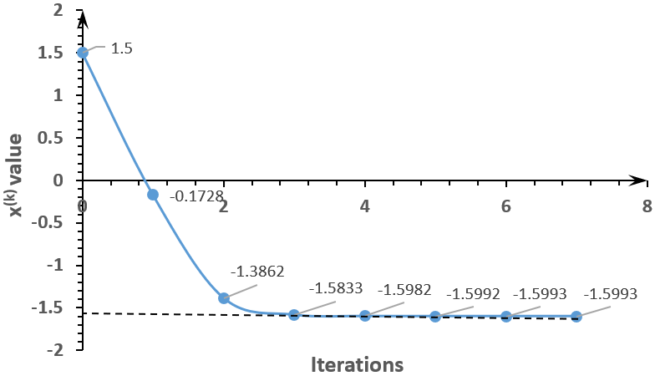

Figure 7: Fixed point iteration

**(b)Newton-Raphson iteration:**

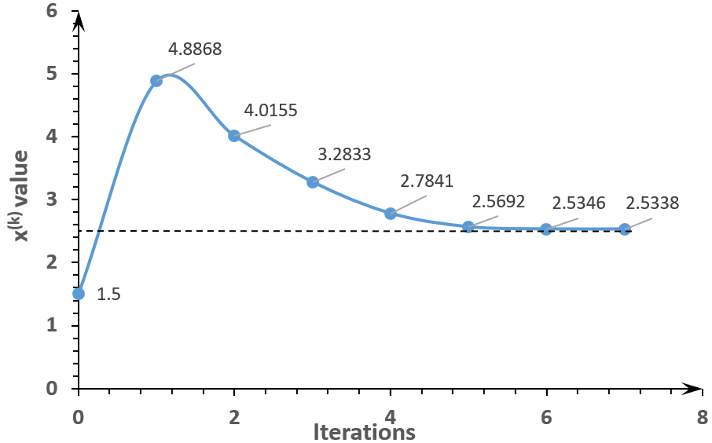

Figure 8: Newton-Raphson iteration

### Problem 8

$$f\left(x\right)=\sin{x}+\frac{x}{10}=0$$

**(a) Plots and roots**

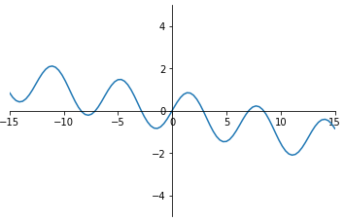

Figure 9: Plot of $f\left(x\right)=0$

There are seven roots. The roots are -8.4232, -7.0681, - 2.8523, 0, 2.8523, 7.0681, 8.4232.

**(b) Factor out one root**

Choose 8.4232 as the root to be factored out.

Then $g\left(x\right)=f(x)/(x-8.4232)$

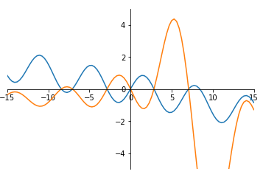

Figure 10: Plot of $f\left(x\right)=0$ and $g\left(x\right)=0$. Blue line for $f\left(x\right)$, and yellow line for $g\left(x\right).$

For $g\left(x\right)$, there are six roots. The roots are -8.4232, -7.0681, - 2.8523, 0, 2.8523, and 7.0681. They are the same as the roots of $f\left(x\right)$, except for $x=8.4232$

**(c) Factor out three roots**

Choose 8.4232, -7.0681 and 2.8523 as the roots to be factored out.

Then $g\left(x\right)=f(x)/(x-8.4232)(x+7.0681)(x-2.8523)$

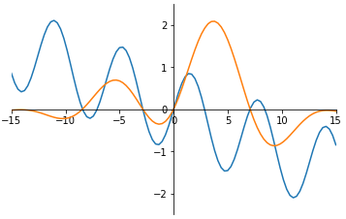

Figure 11: Plot of $f\left(x\right)=0$ and $g\left(x\right)=0$. Blue line for $f\left(x\right)$, and yellow line for $g\left(x\right).$

For $g\left(x\right)$, there are four roots. The roots are -8.4232, - 2.8523, 0, and 7.0681. They are the same as the roots of $f\left(x\right)$, except for $x=$ 8.4232, -7.0681 and 2.8523.

**(d) Problems**

1.For some equations, x = 0 can be a possible root. However, it`s unable with that root.

2.By factoring out some roots, the function g(x) may become quite complicated, and it`s even harder to get the derivative.